Model Creation
- Defining datasets for Input and Output

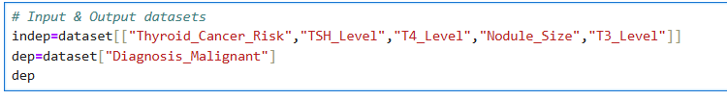
- Splitting Training and Test set
test_size = 1/3 one third of the data will be used for testing, other for training.

- Build and Train the mode
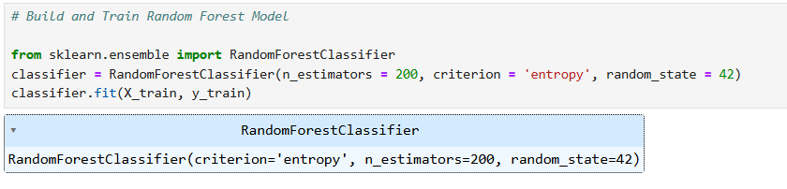
200 no. of trees , entropy splitting criteria
.fit(X_train, y_train) → trains the model using training data

- Making Predictions
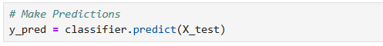
Making predictions for test data by using trained model

- Evaluating the Model
To assess the model thoroughly, the following metrics were calculated:
✔ Accuracy
Measures the percentage of correct predictions made by the model.
✔ Precision
Indicates how many predicted malignant cases were actually malignant.
Important in medical diagnosis to reduce false alarms.
✔ Recall (Sensitivity)
Measures how many actual malignant cases the model successfully detected.
Critical for catching true positive cancer cases.
✔ F1-Score
Harmonic mean of Precision and Recall.
Balances both false positives and false negatives.
✔ ROC Curve (Receiver Operating Characteristic)
Plots the trade-off between True Positive Rate and False Positive Rate.
✔ AUC Score (Area Under Curve)
Represents how well the model differentiates between malignant and benign cases.

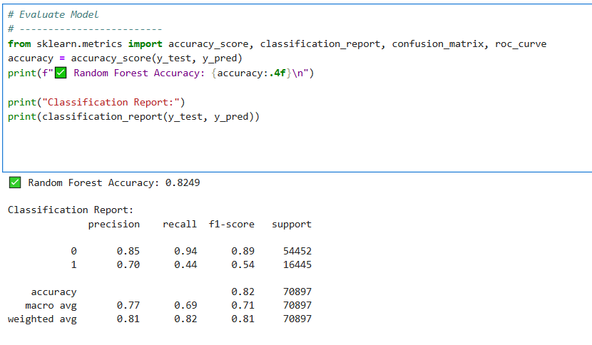
Accuracy – 82%
Precision :
Precision tells you how many of the positive predictions were actually correct.
70% Higher precision = fewer false alarms (fewer people wrongly predicted as at risk).
Recall:
Recall tells you how many of the actual positive cases were correctly identified.
44% Higher recall = fewer missed actual risk cases (model is sensitive in catching positives).
F1-Score :
F1-score is the harmonic mean of precision and recall — it gives a single metric that balances both.
54% Higher F1 means a good balance between catching actual positives and avoiding false alarms.
Summary:
- The Random Forest Classifier achieved an accuracy of 82.49% on the test dataset.
- Precision for class 0 (non-risk cases) is 0.85, while for class 1 (risk cases) it is 0.70.
- Recall for class 0 is high (0.84), but comparatively lower (0.44) for class 1, indicating that some high-risk cases were missed.
- The weighted average F1-score of 0.81 reflects an overall strong and balanced model performance.

- Evaluation - ROC
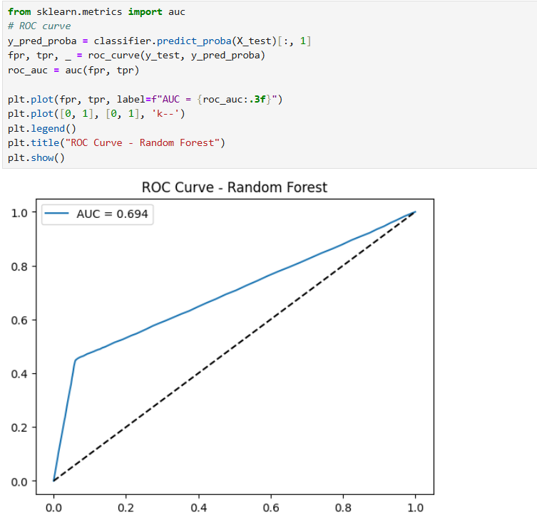

ROC (Receiver Operating Characteristic) curve is a graphical plot used to show the performance of a classification model at different threshold values.
- The ROC curve shows how the model’s sensitivity (True Positive Rate) and 1 - specificity (False Positive Rate) change as you move this threshold.
- X-axis: False Positive Rate (FPR)
→ Percentage of healthy patients wrongly predicted as thyroid risk.
- Y-axis: True Positive Rate (TPR)
→ Percentage of actual thyroid-risk patients correctly identified.
- Each point on the curve represents a model’s performance at a different probability threshold.
AUC (Area Under the ROC Curve) is a numerical summary of the ROC curve — it measures how well the model distinguishes between the two classes (risk vs. no risk).
- AUC = 1.0 → Perfect model (flawless distinction)
- AUC = 0.5 → Random model (like tossing a coin)
- AUC between 0.7–0.8 → Fair
- AUC between 0.8–0.9 → Good
- AUC above 0.9 → Excellent
- The model achieved an AUC score of 0.694, indicating a moderate discriminative ability.
- This means that approximately 69% of the time, the model correctly ranks a patient with thyroid risk higher than one without risk.

- Feature Importance Plot
A Feature Importance Plot shows how much each feature (input variable) contributes to the model’s predictions.
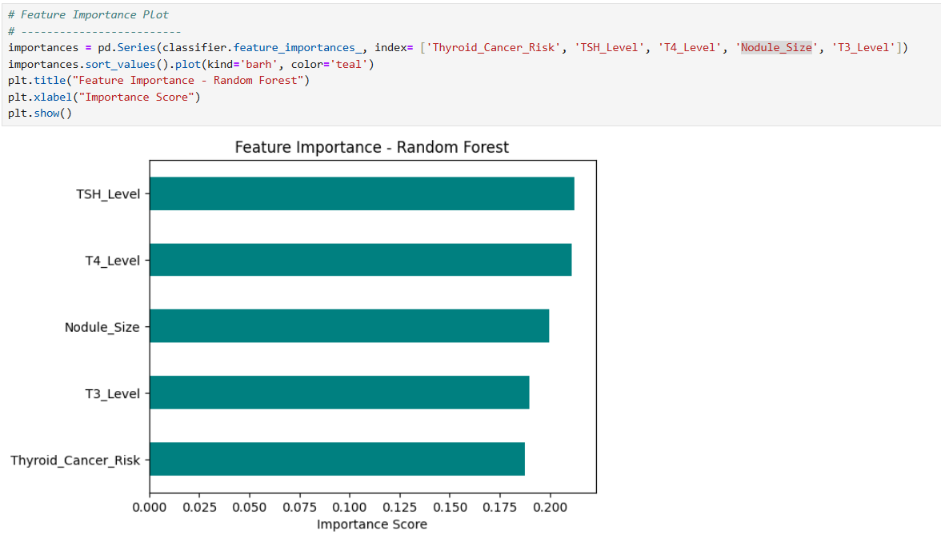

Feature importance plot shows TSH_Level as the highest bar — it means the model relies heavily on TSH levels to decide the diagnosis.
- Hyperparameter Tuning
To check whether the accuracy is increased with any other parameter we are using grid search .
Grid Search tests different combinations of hyperparameters for your model and finds the one that gives the best accuracy or performance metric (like F1-score, ROC-AUC, etc.).
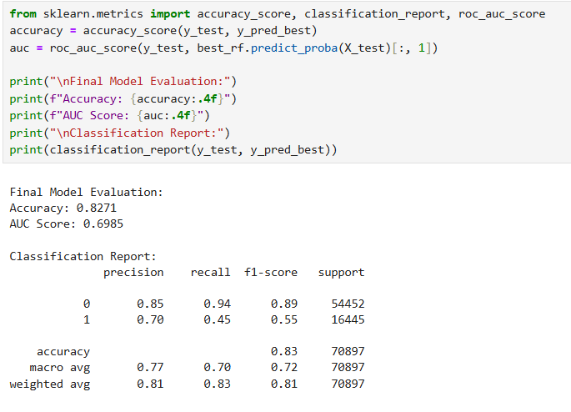
Before grid search
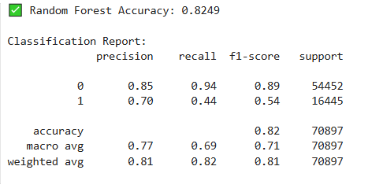

Grid search results
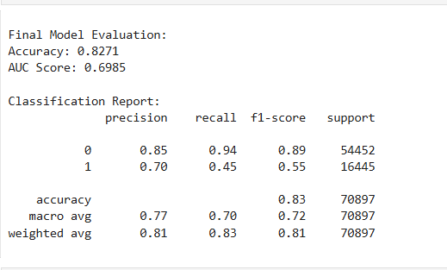
- Grid Search helped fine-tune the model and resulted in consistent, slight improvements across key metrics including accuracy, AUC score, and performance on the malignant class.
- While the improvements are not large, the optimized model is more stable and reliable than the initial version.

- Saving the best model

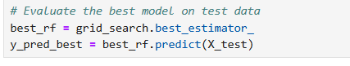
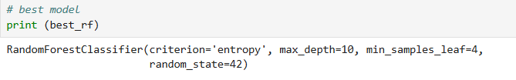
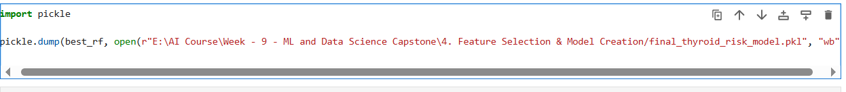Model saved by using pickle.
- Deployment File
Created a separate file for deployment. Will predict the output for User Input.
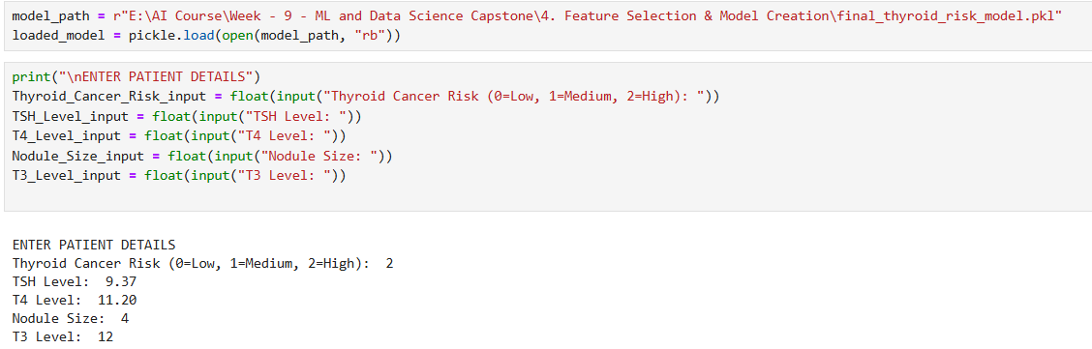

User Input provided.

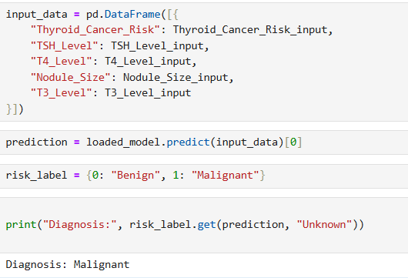
- Got the input in a dataframe.
- By using the loaded model predicting the input dataframe & saving to prediction.
- Used dictionary called risk_label to convert the model’s prediction (0 or 1) into a readable diagnosis.

- The dictionary maps numbers to text:
- 0 → Benign
- 1 → Malignant
• .get(prediction) looks for the prediction (0 or 1) in the dictionary.
• If the prediction exists → it returns the correct label (“Benign” or “Malignant”).
• If the prediction is not found → it returns "Unknown" instead of giving an error.

Prediction Result:
Here it predicted the patient has Malignant Nodule.

